**Sqoop homework**

**Create a table named “stocks” in MySQL with the following sample schema and data.**

create table stocks  
(  
 id int not null primary key,  
 symbol varchar(10),  
 quote_date datetime,  
 open_price float,  
 high_price float,  
 low_price float  
);  
  
insert into stocks  
values (1, 'AAPL', '2009-01-02', 85.88, 91.04, 85.16),  
 (2, 'AAPL', '2008-01-02', 199.27, 200.26, 192.55),  
 (3, 'AAPL', '2008-01-03', 86.29, 86.55, 81.19);

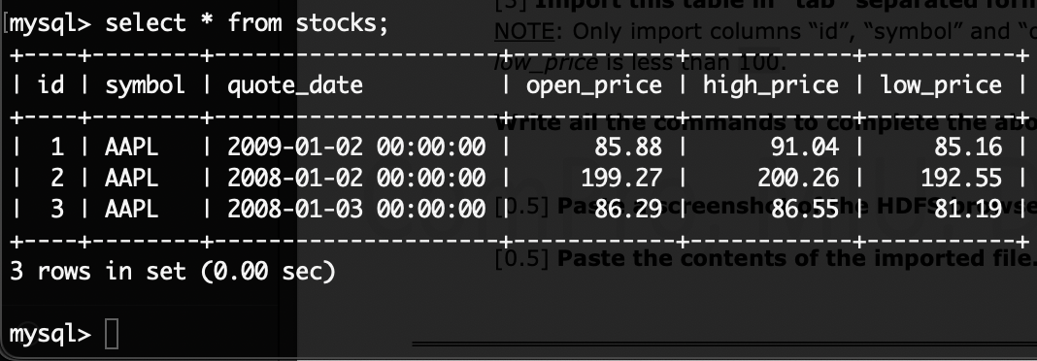

**Import this table in “tab” separated format in HDFS.**

sqoop import --connect jdbc:mysql://quickstart.cloudera/cs523 --username root -P --table stocks --columns "id, symbol, open_price" --where "low_price < 100" --direct --fields-terminated-by "\t" --target-dir=/user/cloudera/sqoopImportOutput

**Paste a screenshot of the HDFS browser to show the imported files.**

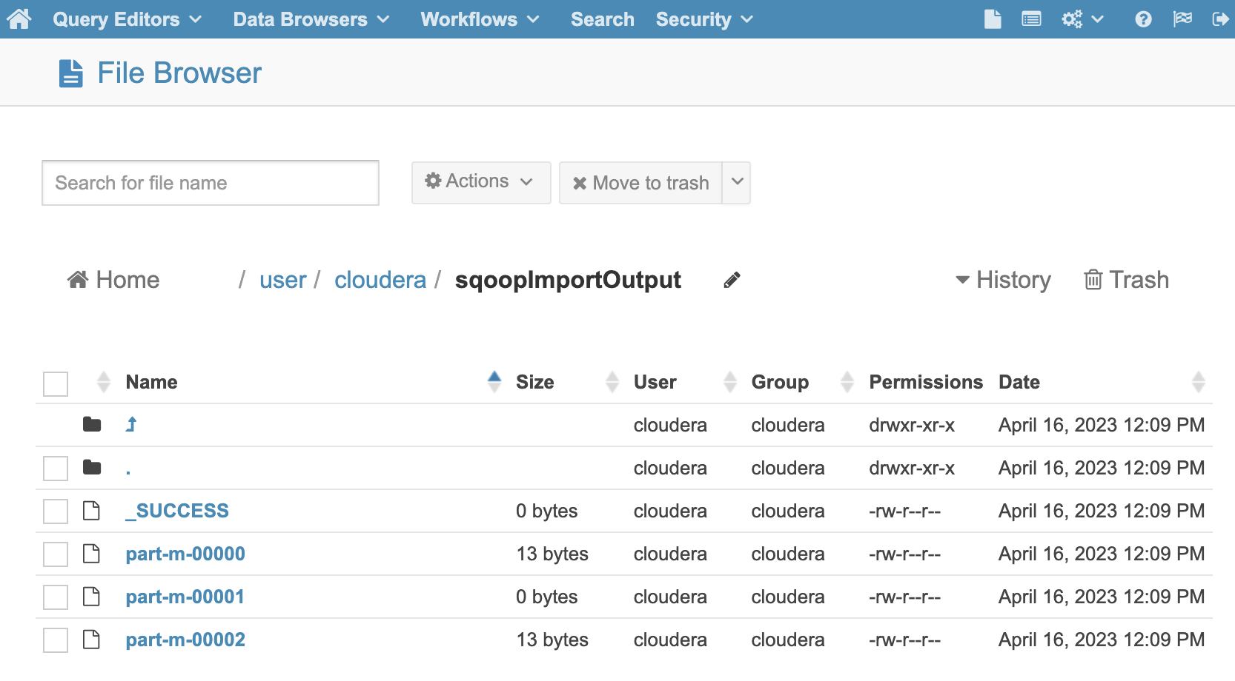

**Paste the contents of the imported file.**

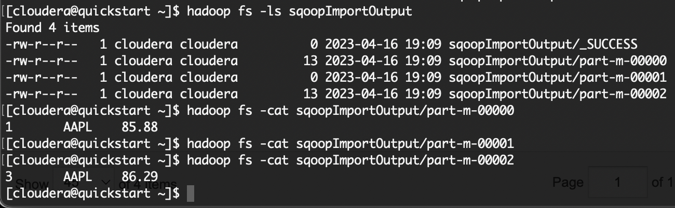

**Flume homework**

**Create directory /home/cloudera/cs523/flume/conf/ and store conf file as myFlumeConf.conf**

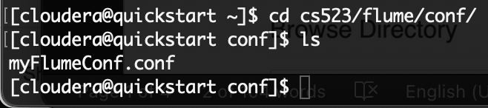

**Create directory /home/cloudera/cs523/flume/log/ to config sources spoolDir**

**Start agent:**

flume-ng agent -n agent1 -c cs523/flume/conf/ -f cs523/flume/conf/myFlumeConf.conf

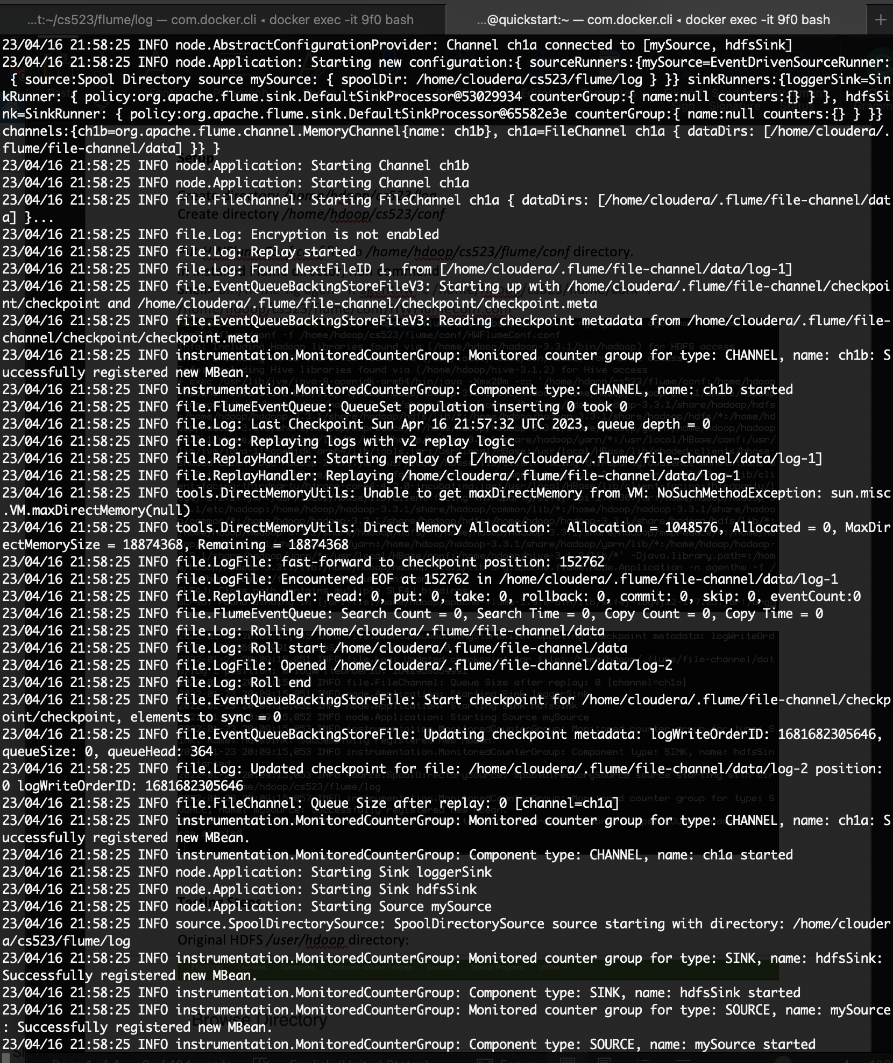

**Create two files log1.txt and log2.txt for testing.**

**Copy file log1.txt to directory /home/cloudera/cs523/flume/log/**

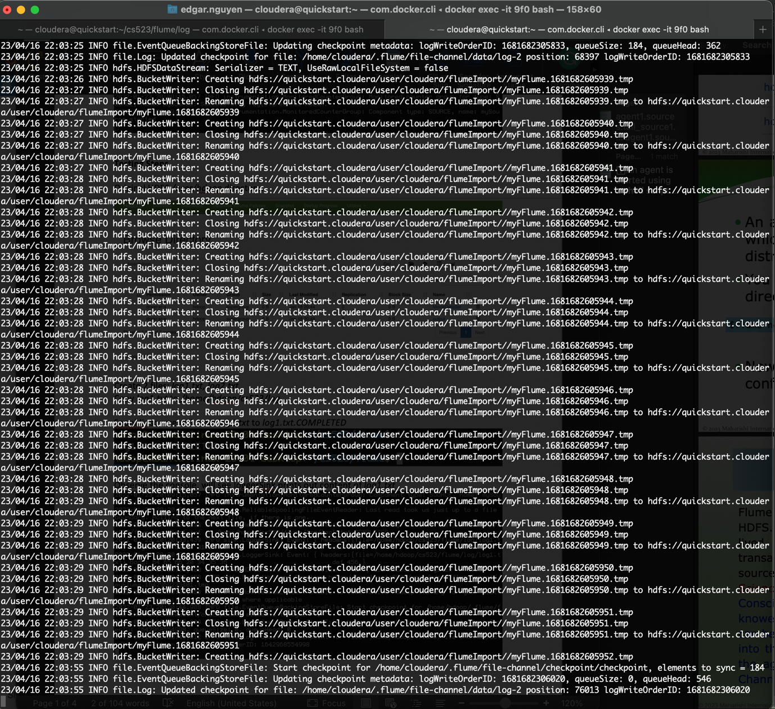

**Copy file log2.txt to directory /home/cloudera/cs523/flume/log/**



**HDFS sink imported:**

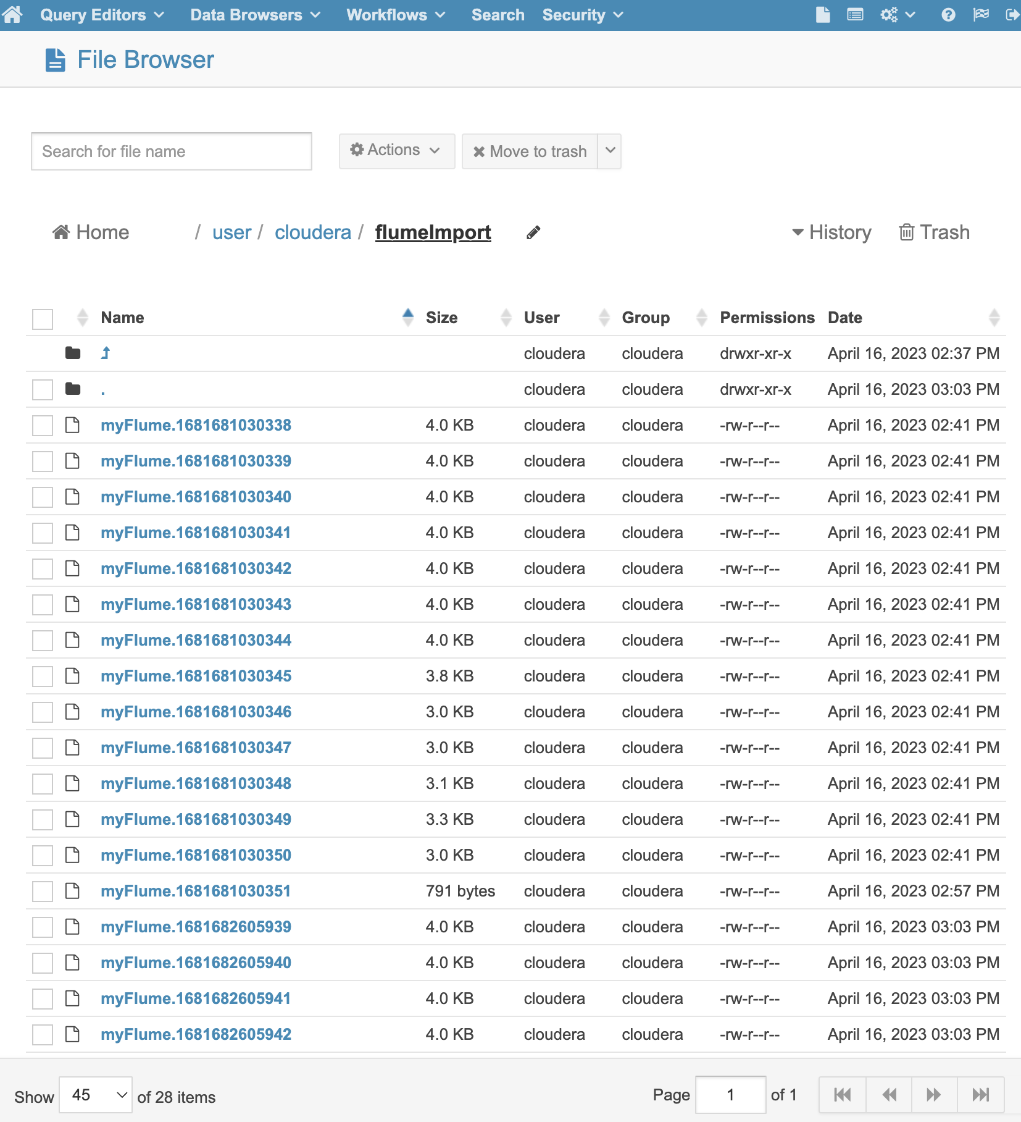

**Spooldir source:**

